## Lab 1 — Load Balance Two Nginx Servers

1. Launch two EC2 instances (`t2.micro` / `t3.micro`).
2. Install nginx on both. Make one serve `Hello from Server A`, the other `Hello from Server B`.
3. Create two security groups: ALB open on port 80 to the internet; instances open on port 80 **only to the ALB's security group**.
4. Create a target group, register both instances, confirm both are `healthy`.
5. Create an internet-facing Application Load Balancer across two AZs, listener on port 80 → target group.
6. Hit the ALB DNS name and refresh. Confirm the message alternates. (Test with `curl` in a loop, not the browser.)
7. Stop nginx on Server A. Watch the target go unhealthy and traffic stop.
8. Enable stickiness on the target group. Refresh again and observe the difference.

**Cleanup:** ALB → target group → instances → security groups.

Step 1: Launch an instance named LB1. Select the AMI(amazon linux and CPU(t2.micro or t3.micro). Name the key (labkey). Keep auto-assign public IP “enable”. Keep the VPC default or can have our own as well. Select a subnet from the dropdown. Then go to security group --- create security group --- give permission to port 22(SSH) and port 80(HTTP). Other details related security group in screenshot. (SSH make it anywhere not myIP)
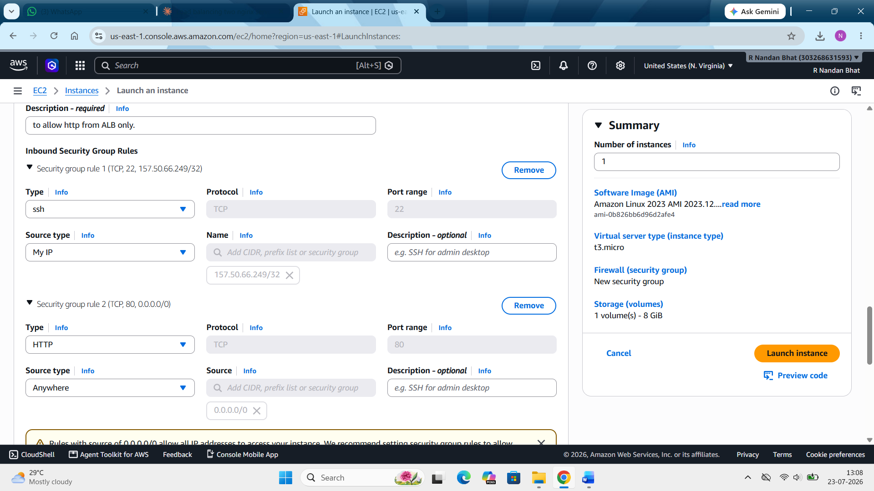

Here we are keeping http anywhere for now. Will change it later when we give permission to ALB.

Step 2: with the same step launch an instance LB2. Here make sure to select the same VPC but the subnet has to be different. Then for security group select existing security group and add the same one added to LB-1. Then click on launch instance.
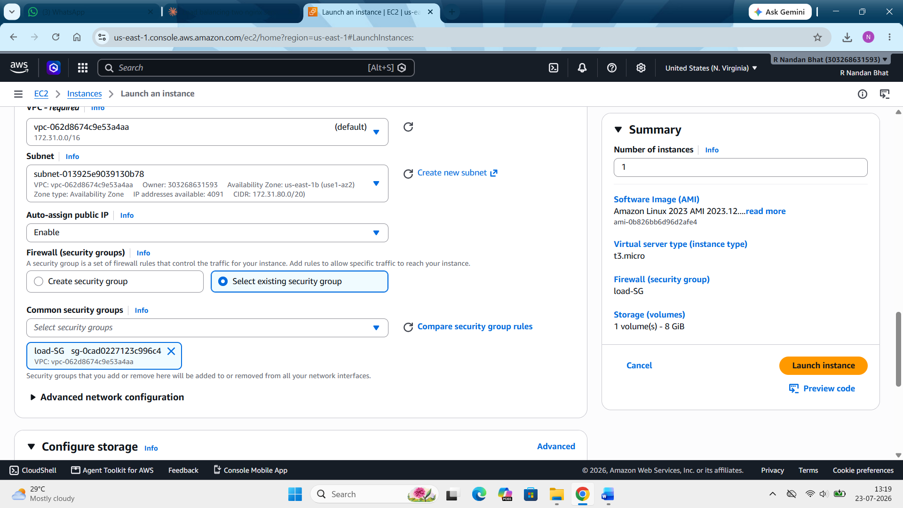
Now here we have launched both the instances

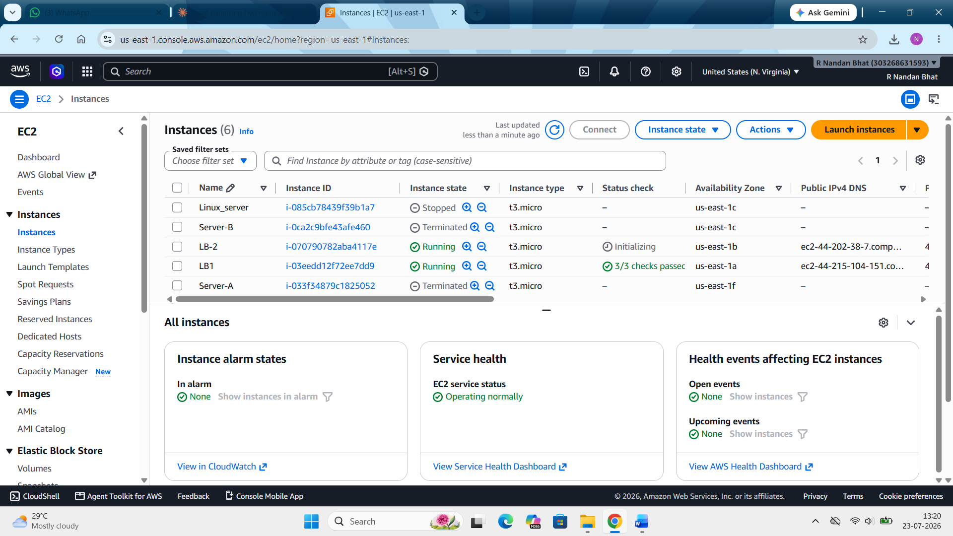
Step 3: Now we have to SSH into the instance LB1 using putty or can do it by direct connect as well. After doing this we have to install nglix in it using the following command.
sudo dnf install -y nginx
echo "Hello from Server A" | sudo tee /usr/share/nginx/html/index.html
sudo systemctl enable nginx
sudo systemctl start nginx
sudo systemctl status nginx
curl localhost
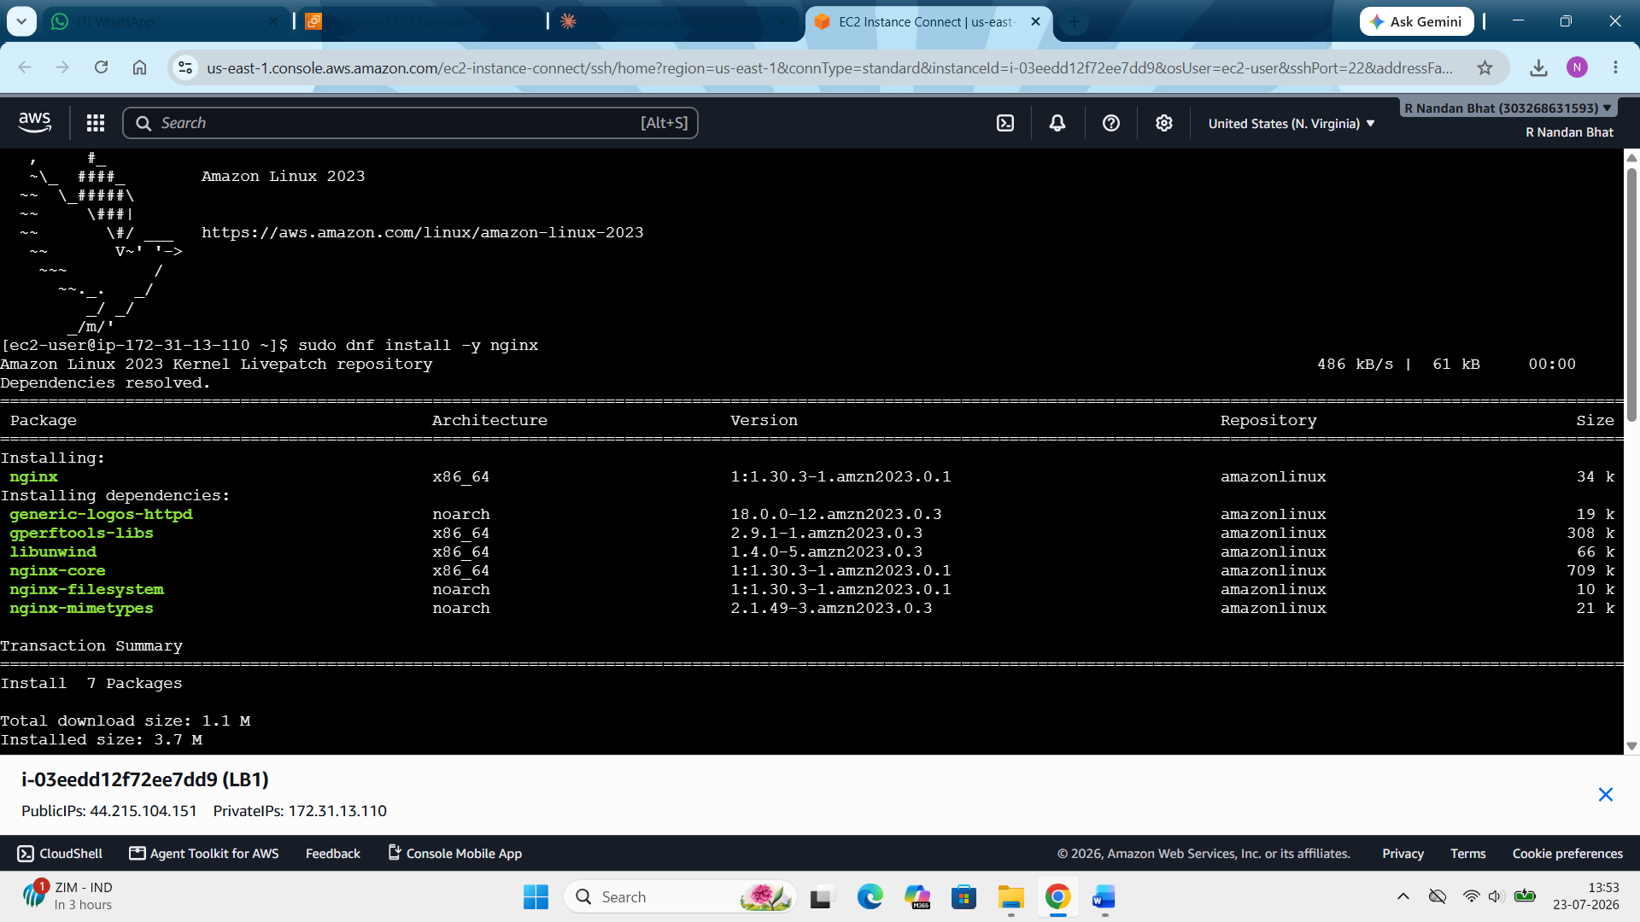
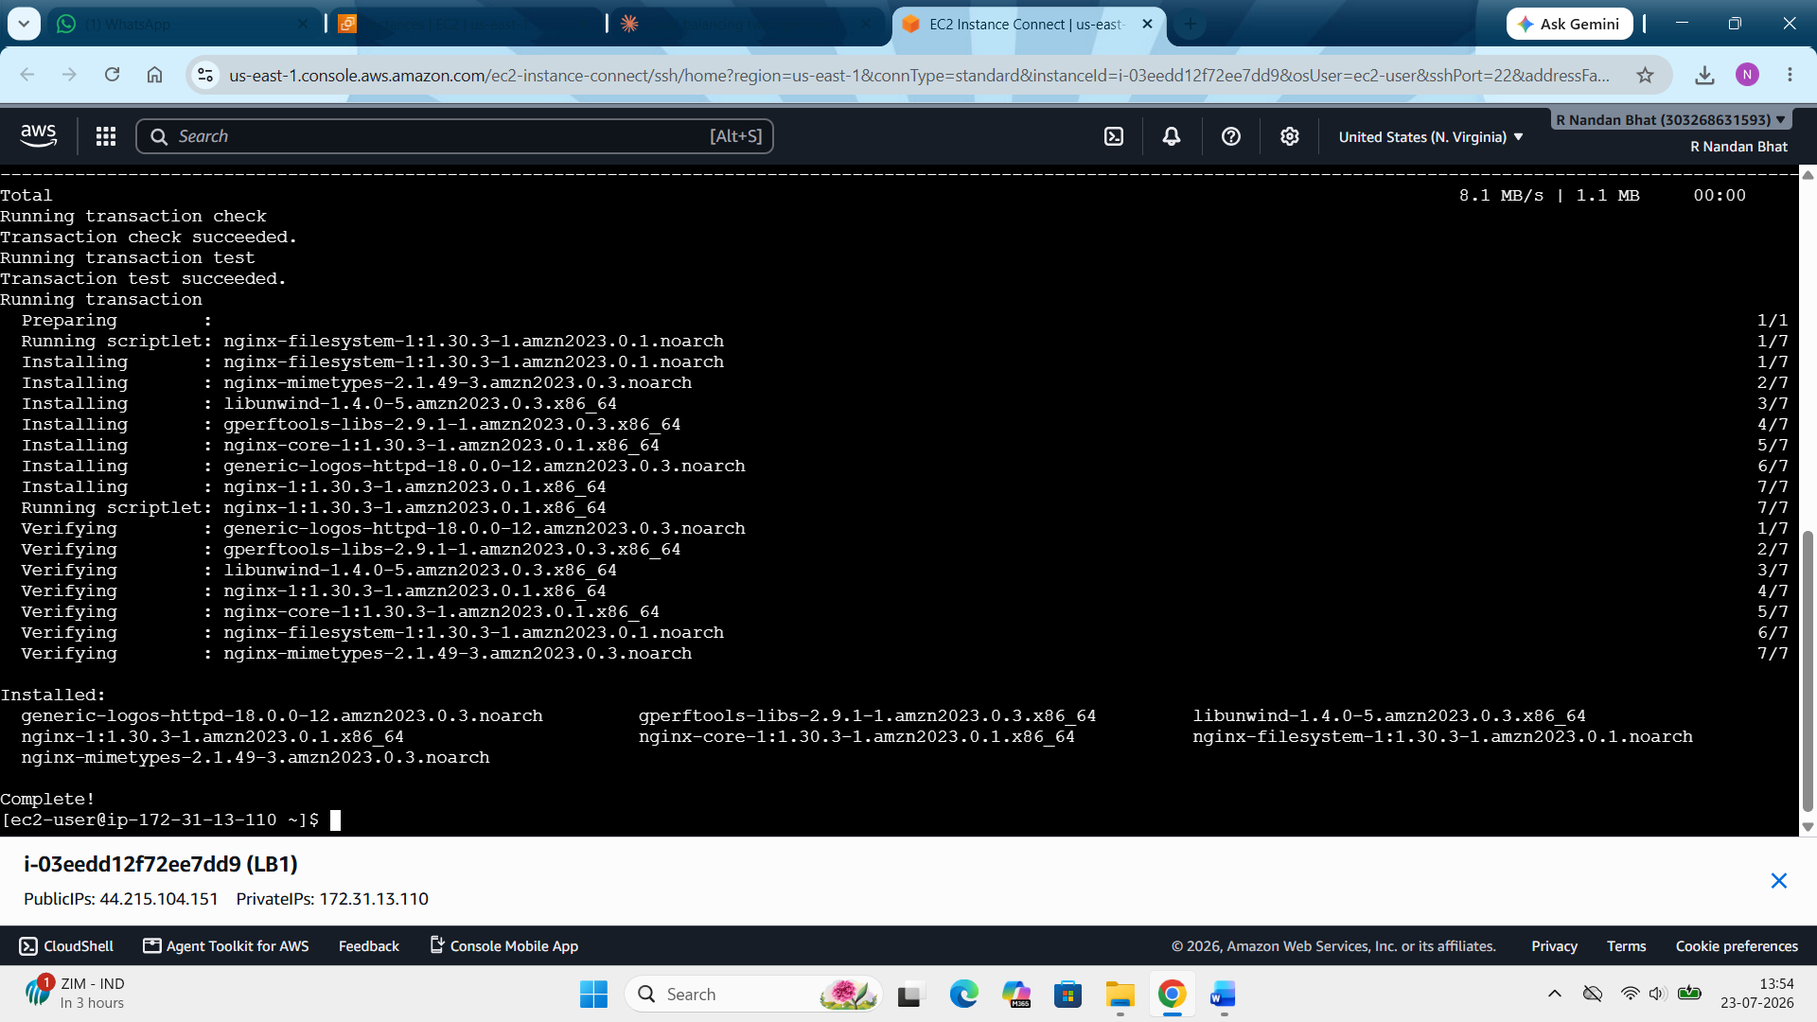
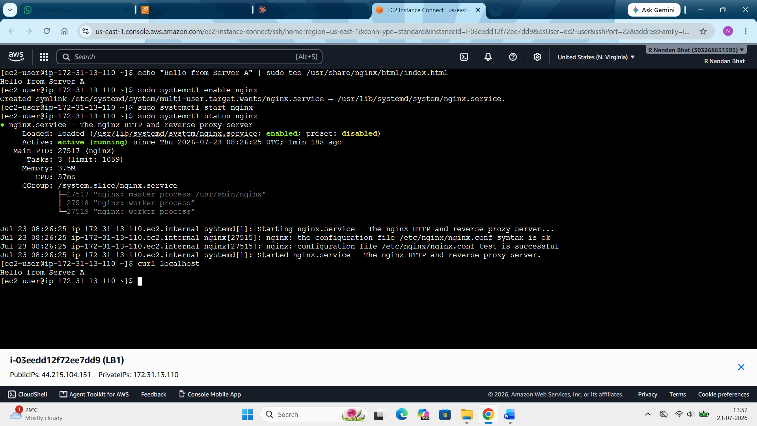

Now do the same for LB2 instance as well following the same steps.
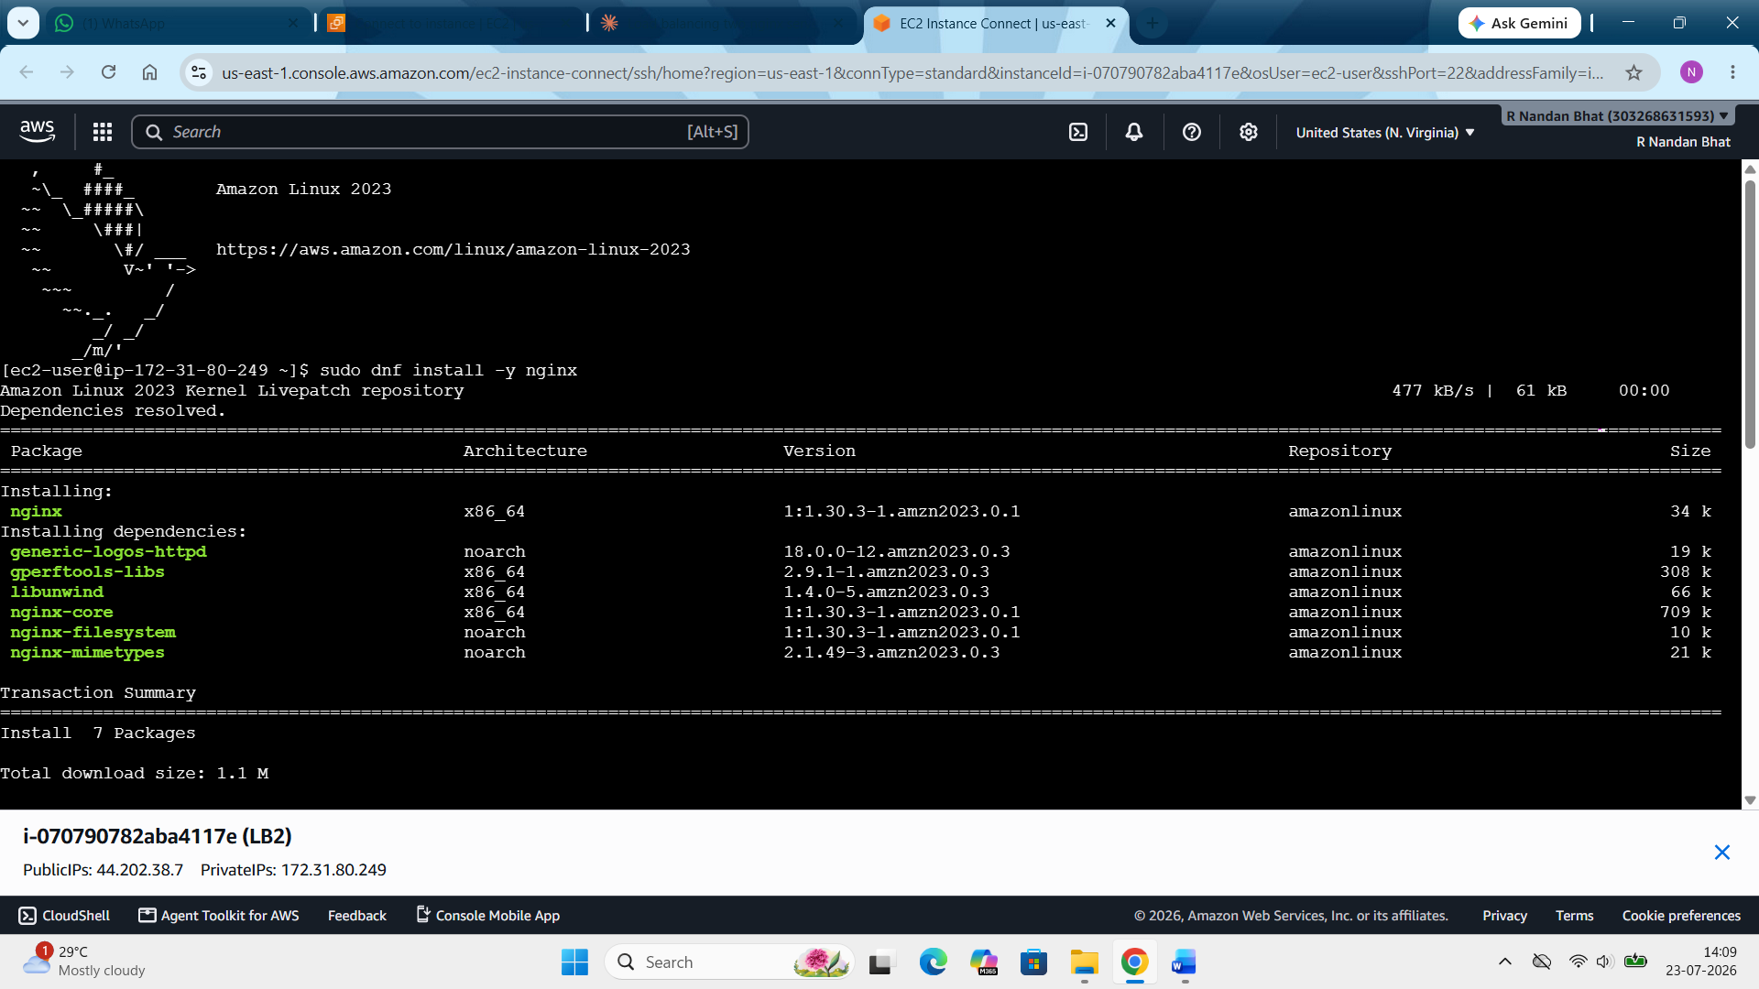

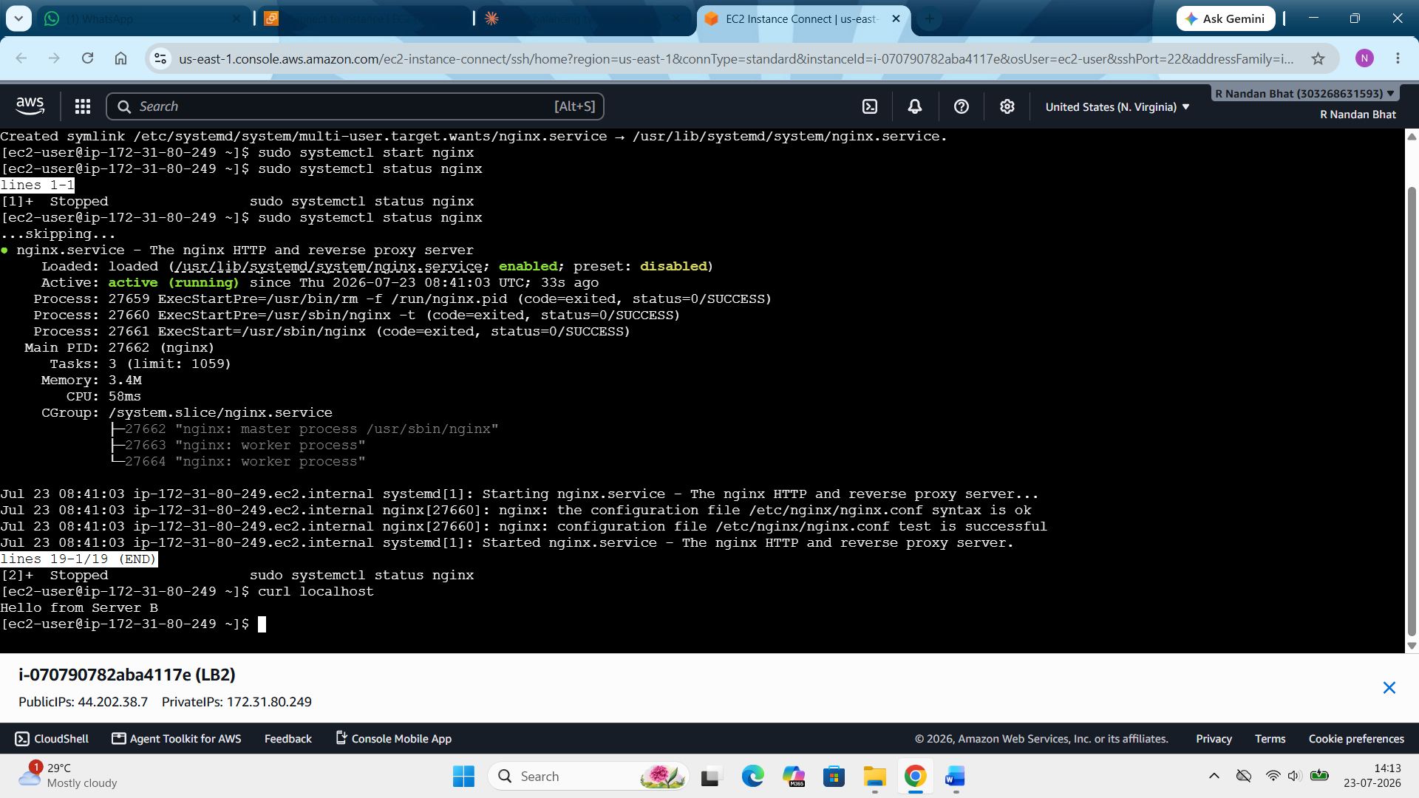

Step 4: Create a target group:
EC2 console --- load balancing ---target groups --- create target group --- target type (instances) --- group name (load-TG) --- Protocol (http,80) --- IP address type (IPv4) --- VPC (same as in instances)
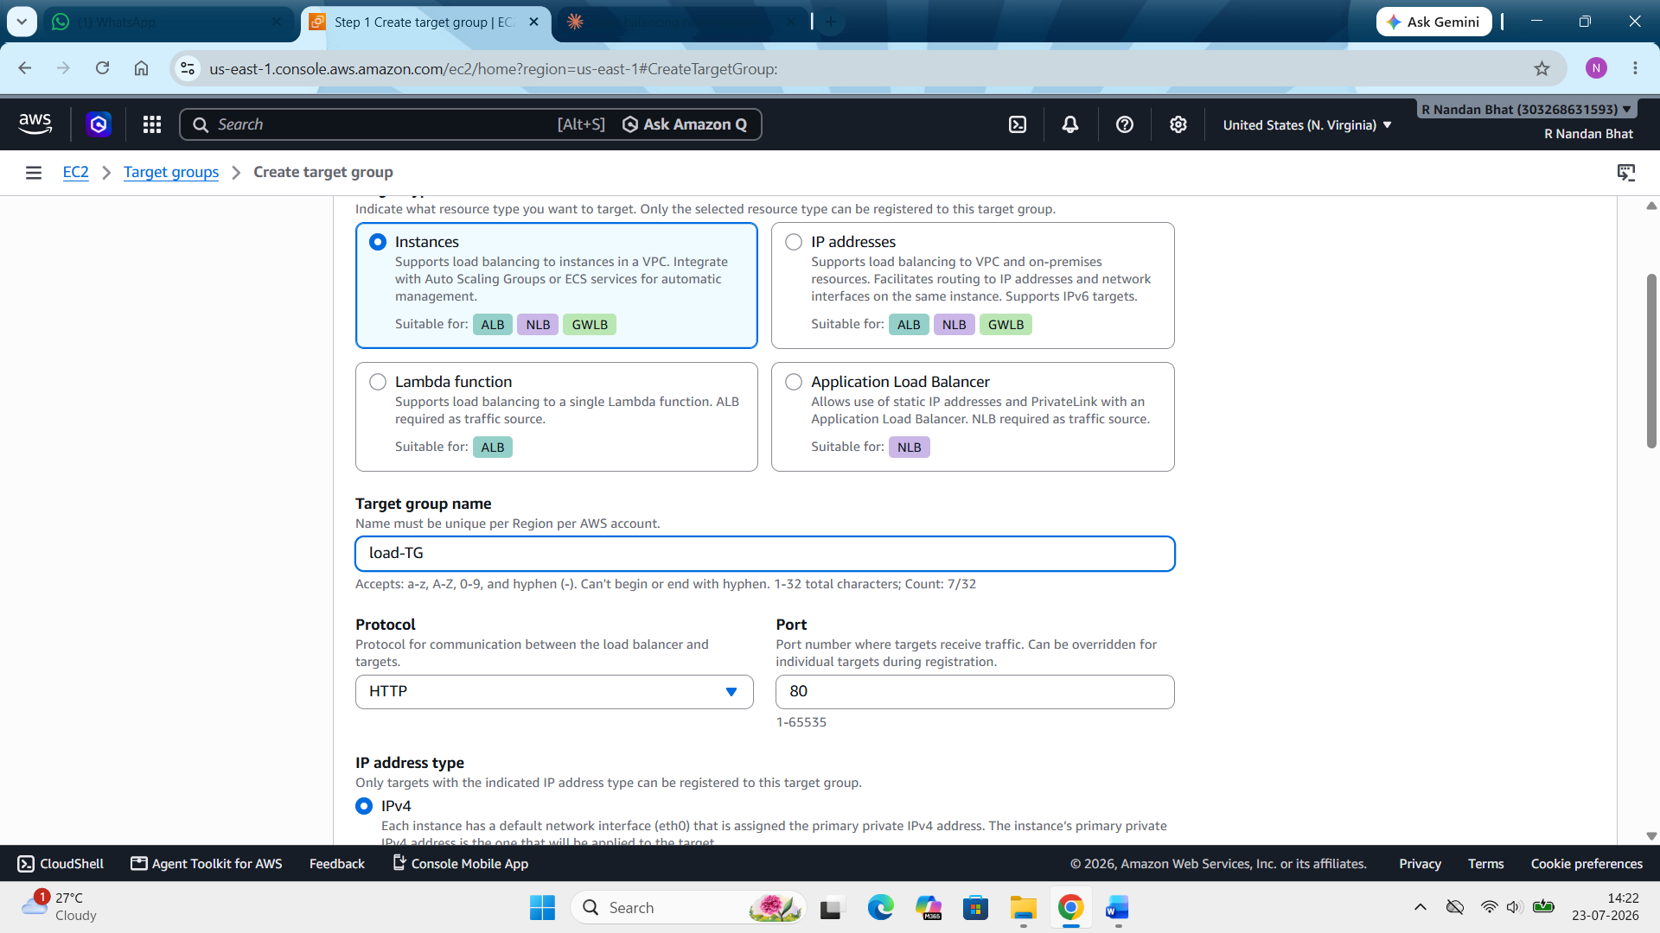
Health check --- protocol (http) --- keep rest default (note: we can change the threshold time in advanced setting if you want. Here we have kept default. Click next.
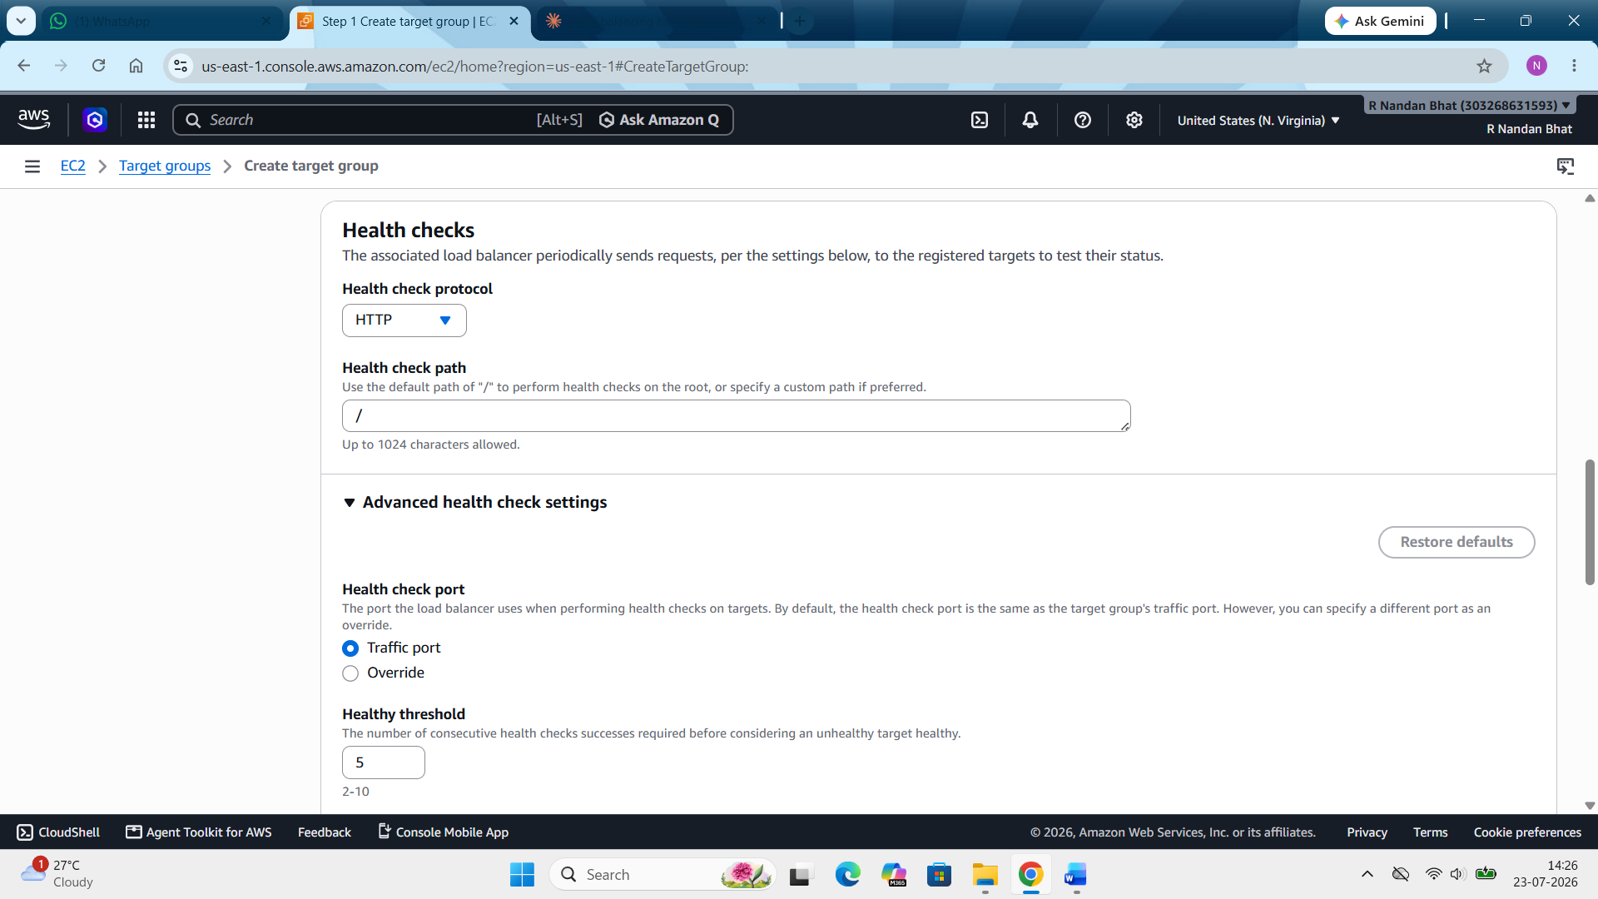

Now in “register target” select the instances. Here they are LB1 and LB2. Make sure the port is 80. An click on “include as pending below”. Then click next. Then create target group.
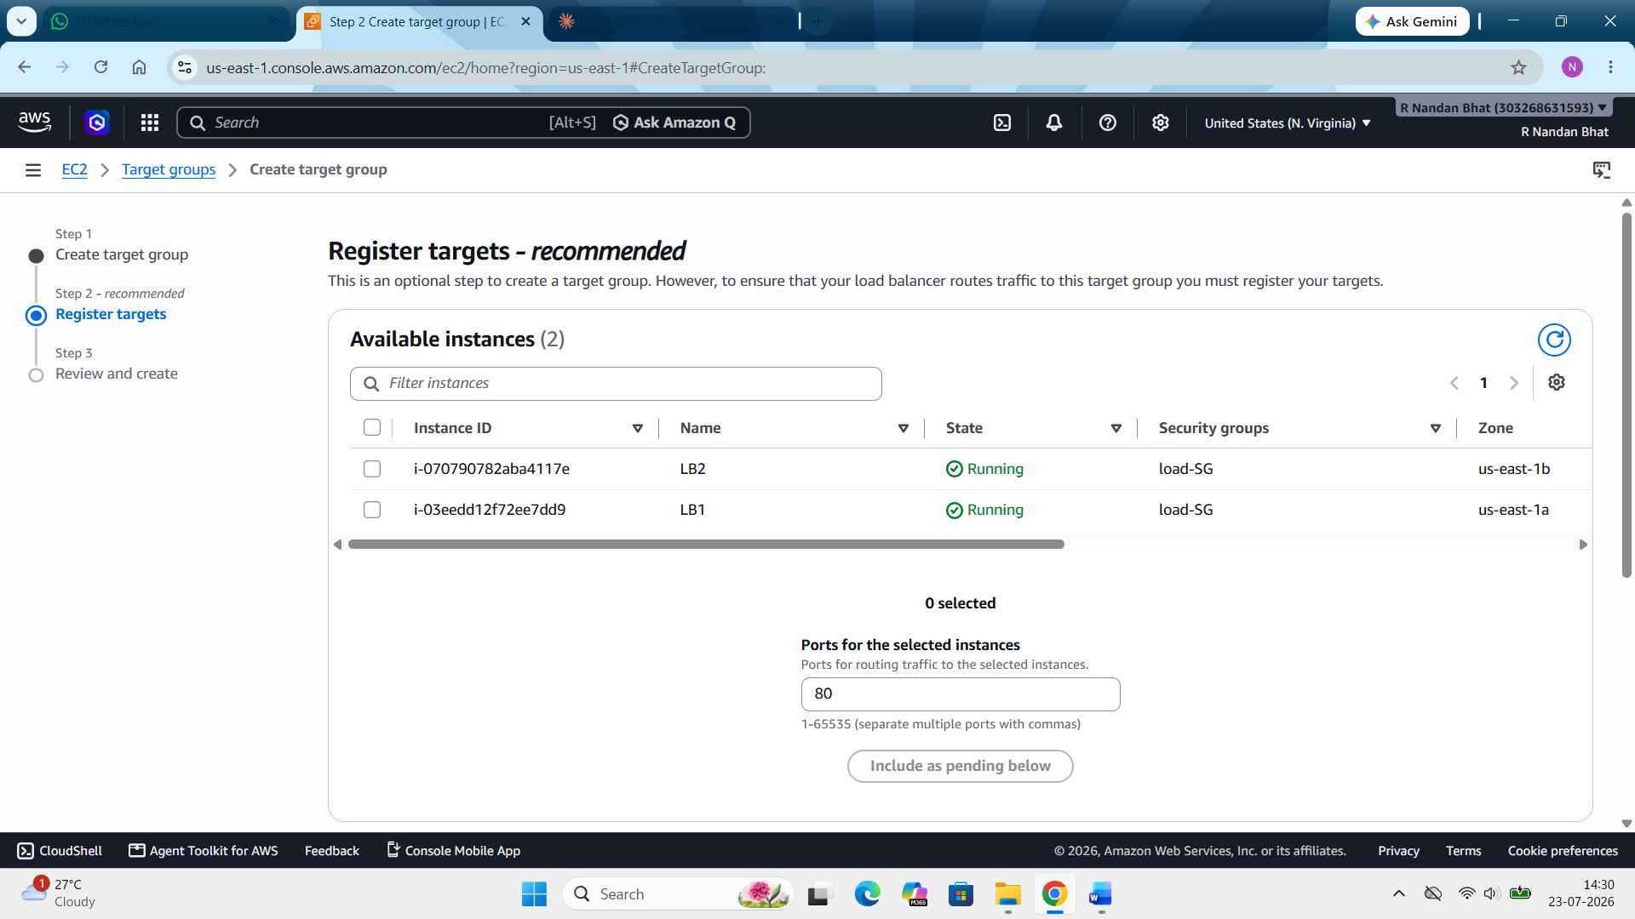

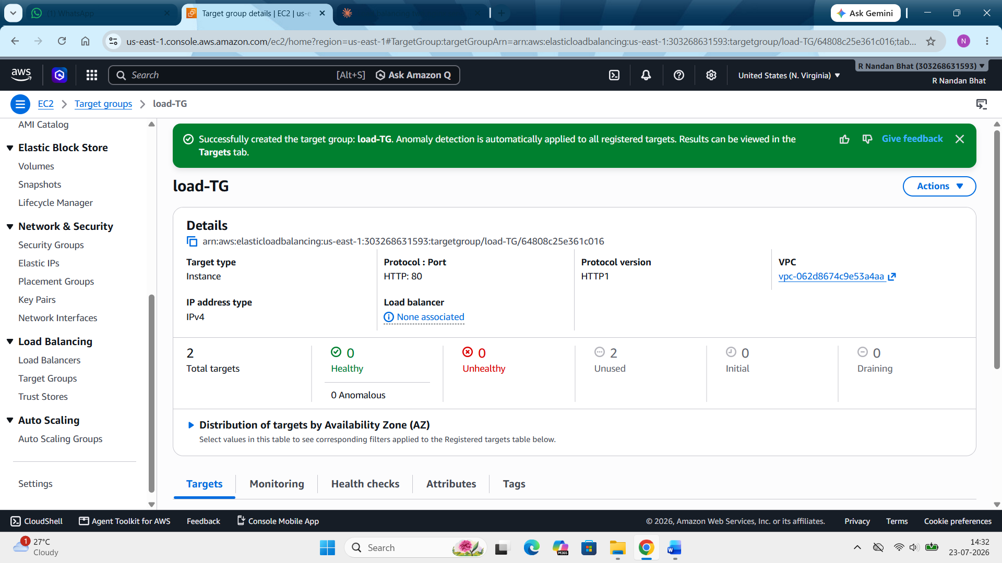

Step 5: Create ALB (application load balancer) security group:
Security group --- create security group --- enter name (ALB1_SG) --- VPC (same as in instance) --- inbound rule (HTTP, 80) --- source (anywhere IPv4) --- create security group

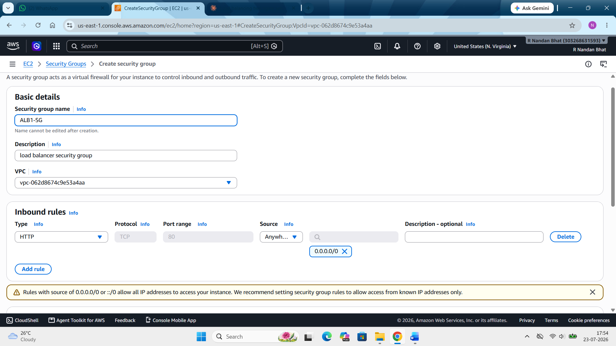
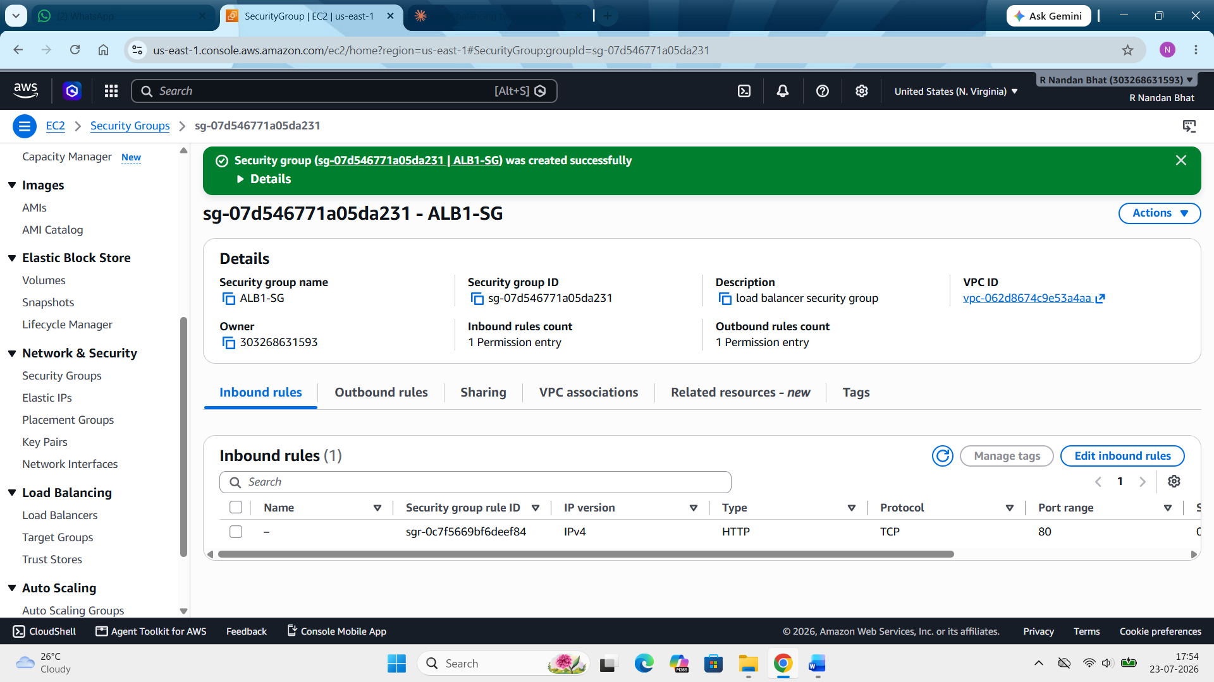

Step 6: Creating application load balancer (ALB):
EC2 --- load balancing --- load balancer --- create load balancer --- application load balancer --- create --- enter name (web-LB) --- scheme should be “internet facing” (default) --- IP type (IPv4) ---
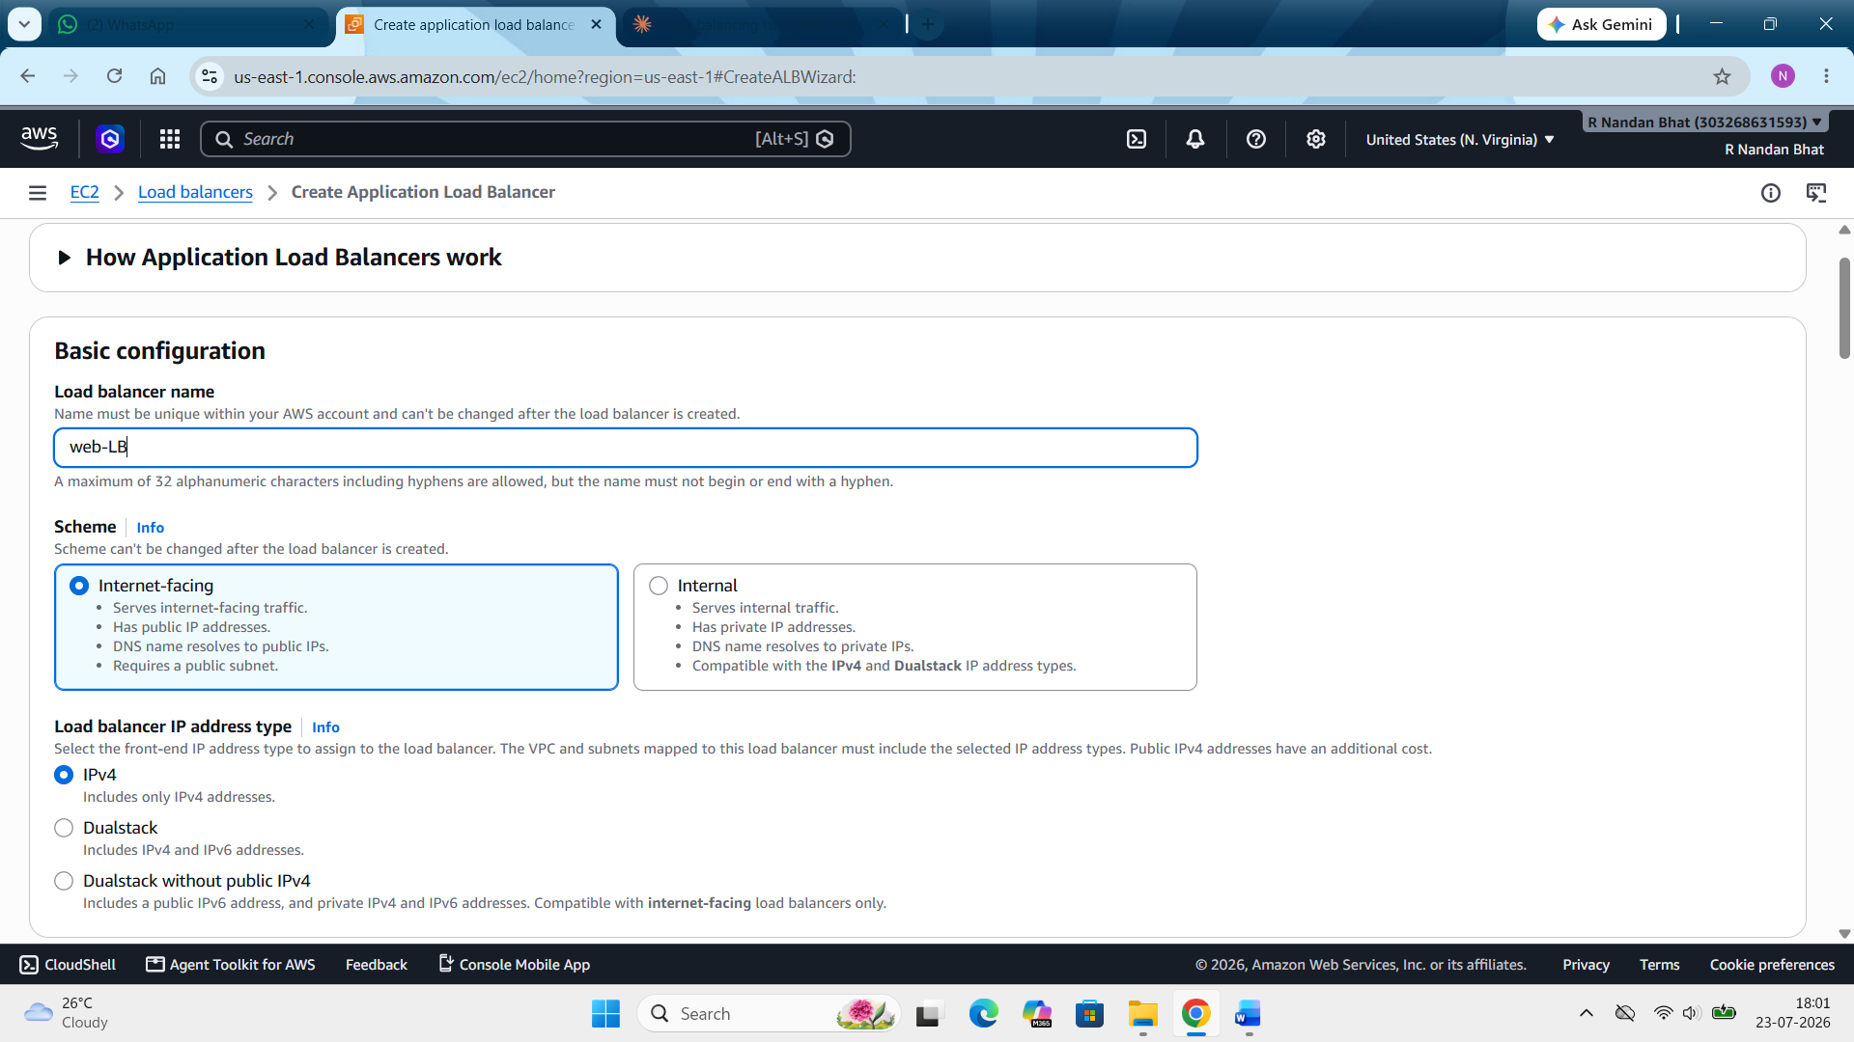

--- network mapping --- VPC (same as before) --- AZ’s and subnet (select the subnet or AZ selected for LB1 and LB2) ---
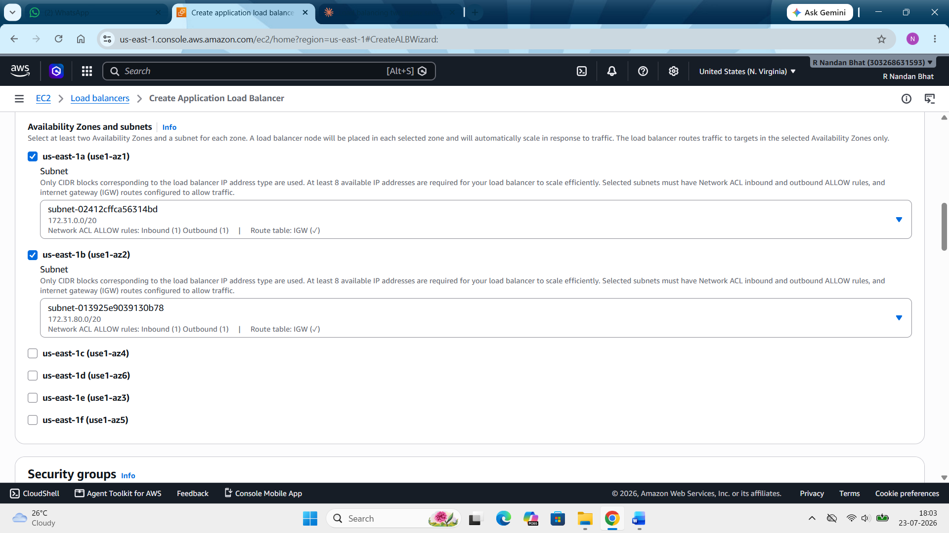
--- security group --- remove default SG if selected automatically --- added created SG (ALB1-SG) ---
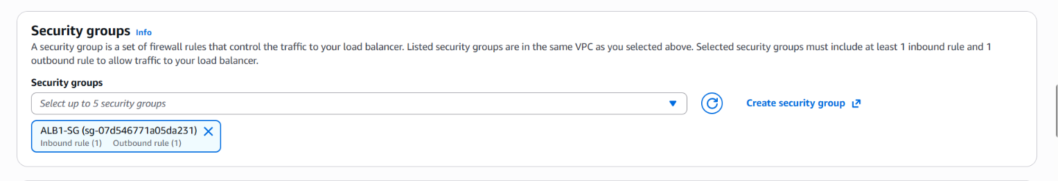
--- listener and routing --- default action --- forward to target groups --- target group (select created load -TG) ---
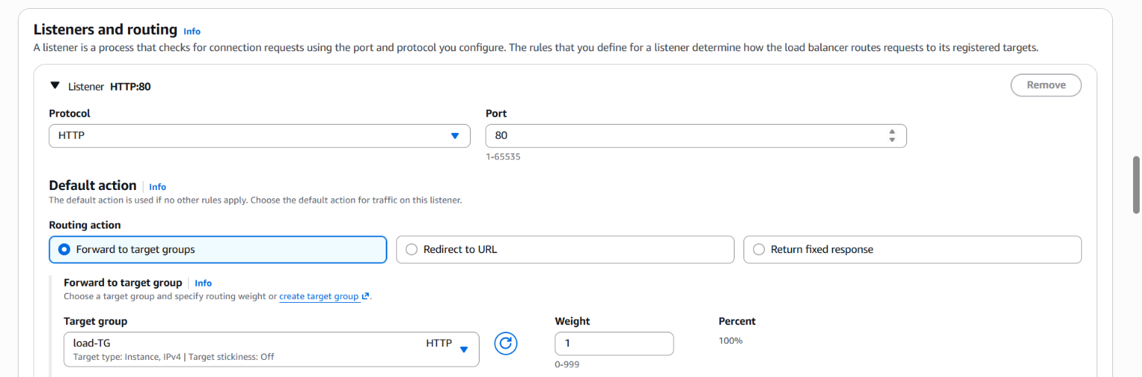

--- create load balancer --- wait till the status turns from “provisioning” to “active”
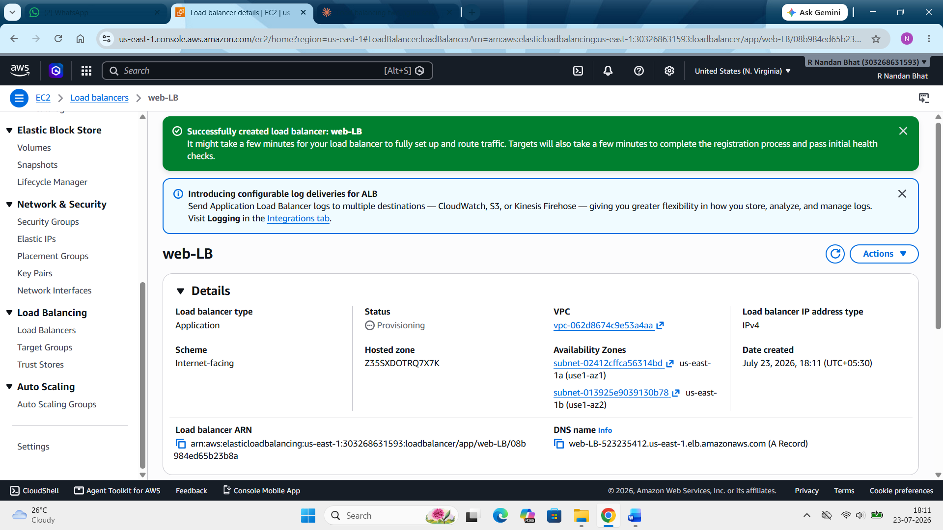

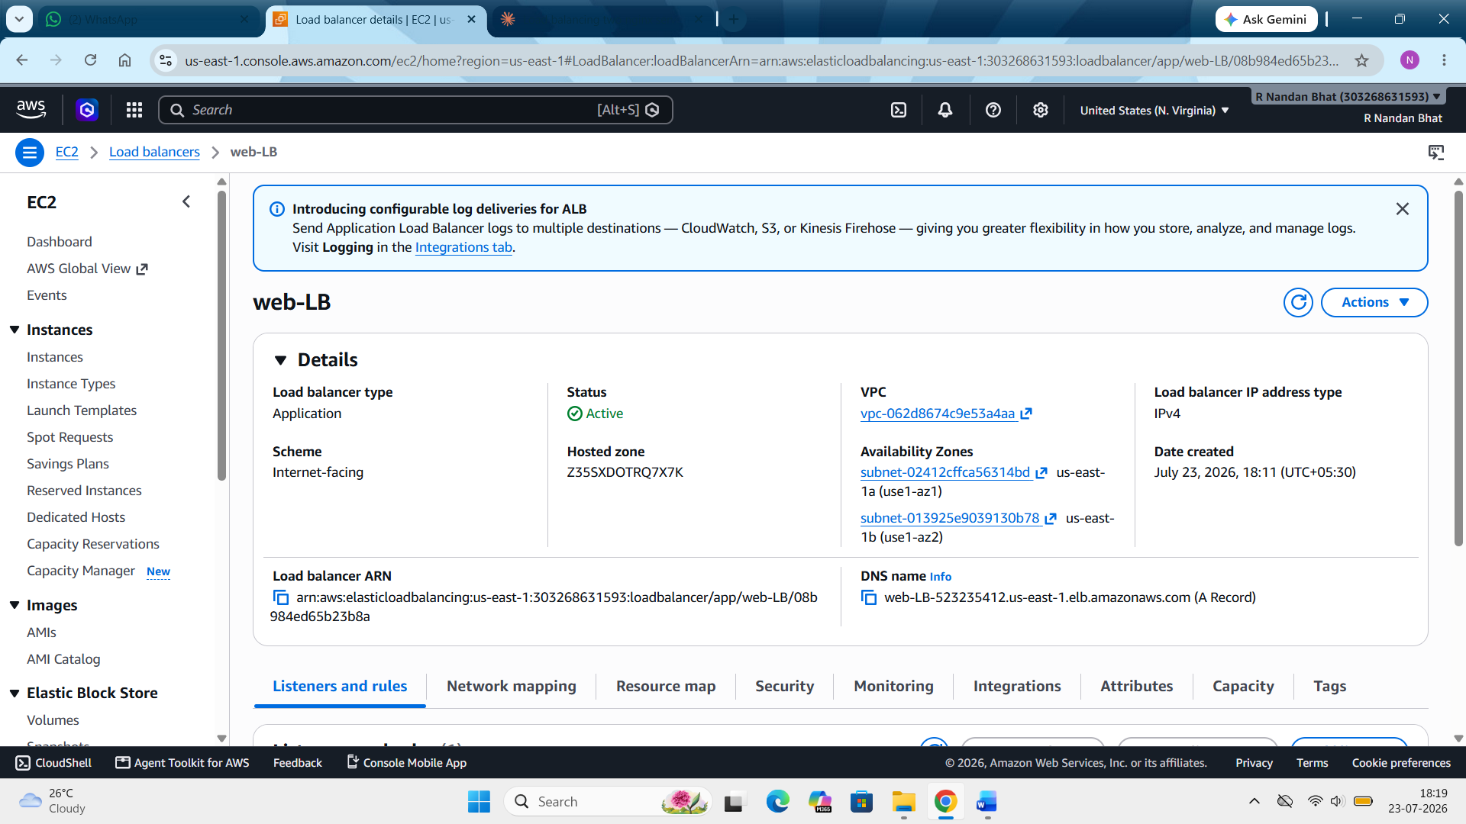

Step 7: Now go back to target group to check the health status of both the instances LB1 and LB2. It should now show health.
EC2 --- load balancing --- target group --- click on the target group --- here we will see the both the health check turn into healthy for LB1 and LB2.

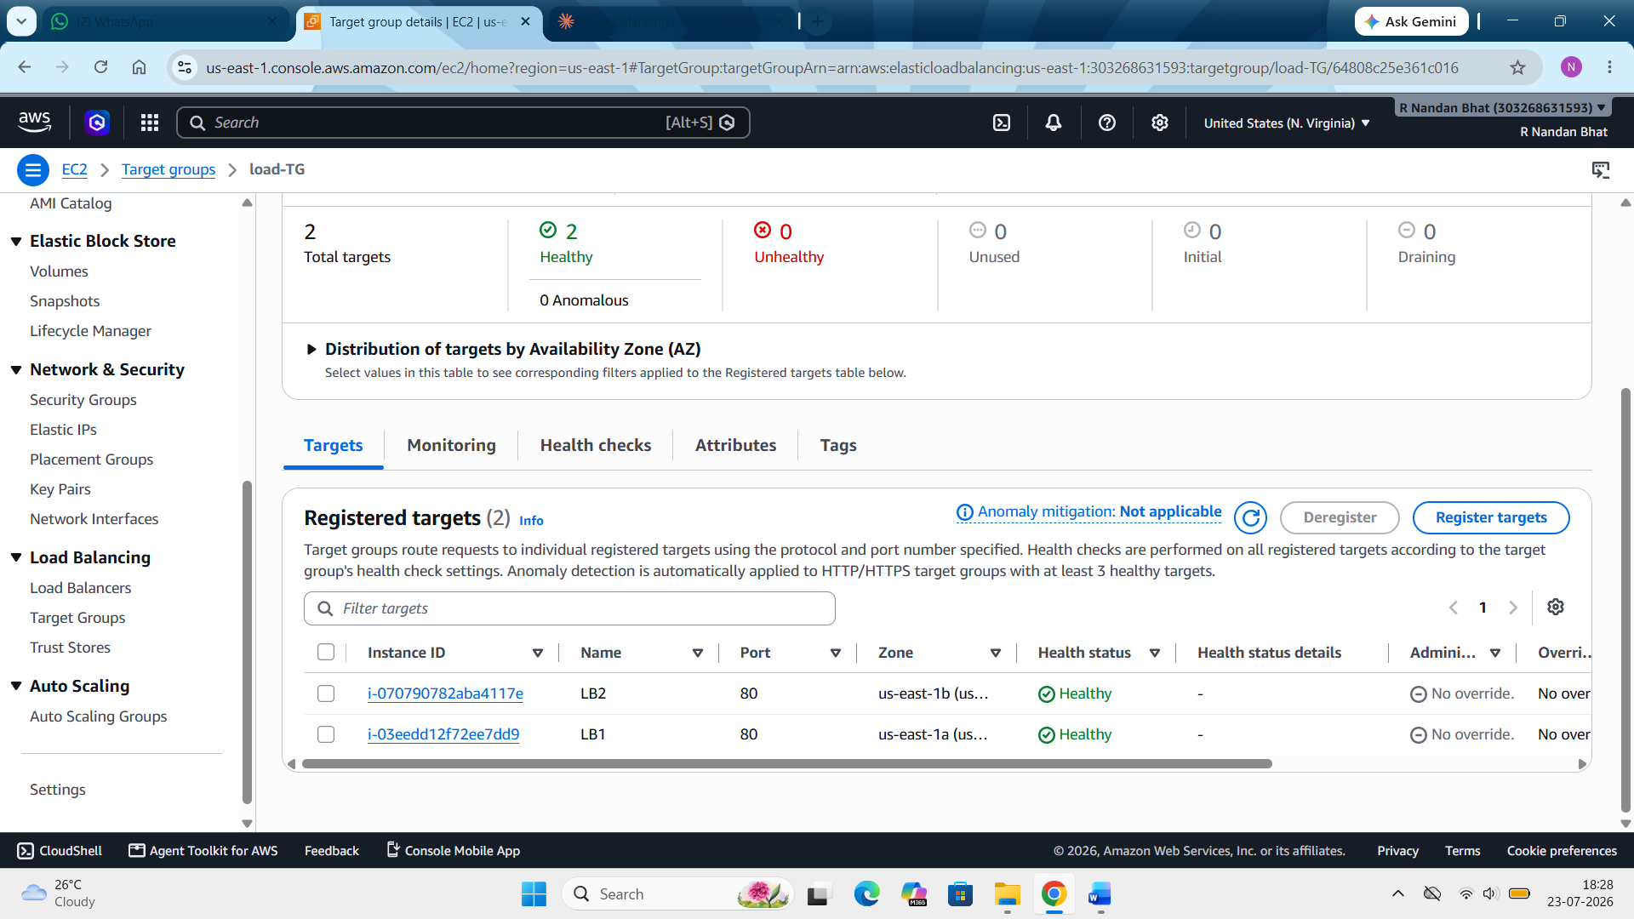

Step 8: Testing the load balancing:
Run curl in loop in power shell (for loop) ---
for ($i=1; $i -le 10; $i++)
{ curl.exe http://web-LB-523235412.us-east-1.elb.amazonaws.com }
(The above command means "Send a curl request to the ALB, print a blank line, and repeat this 10 times." Since the ALB forwards each request to alternating backend servers, you'll see the response text switch between "Hello from Server A" and "Hello from Server B".)
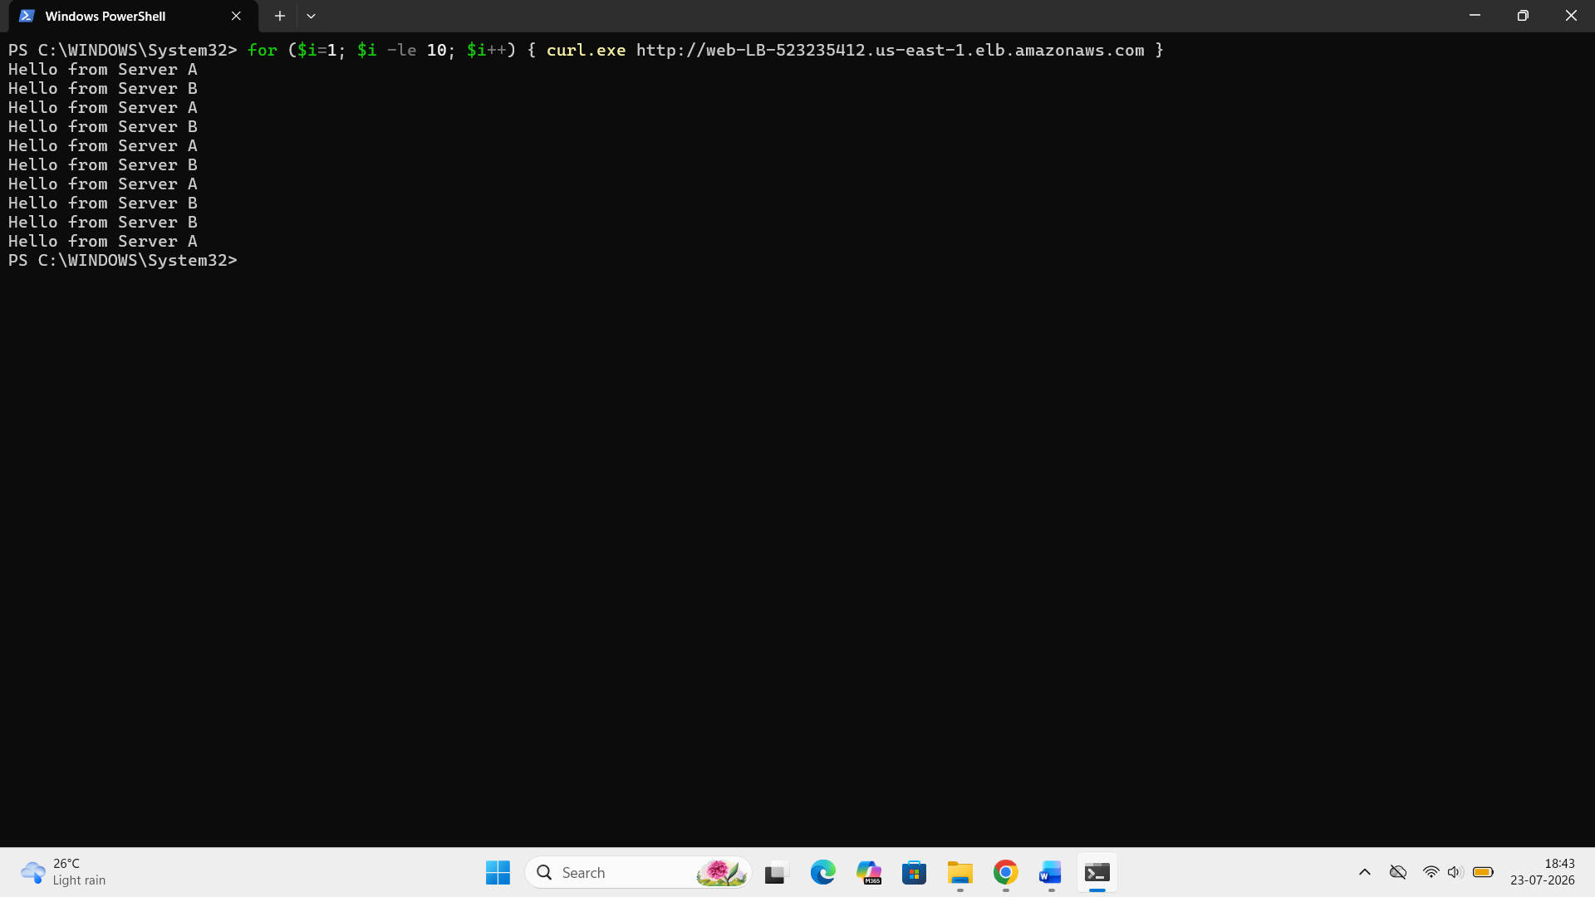
Step 9: Testing fail:
In this we are going to stop the nglix in LB1.
EC2 --- connect instance --- run the following command --- “sudo systemctl stop nginx”
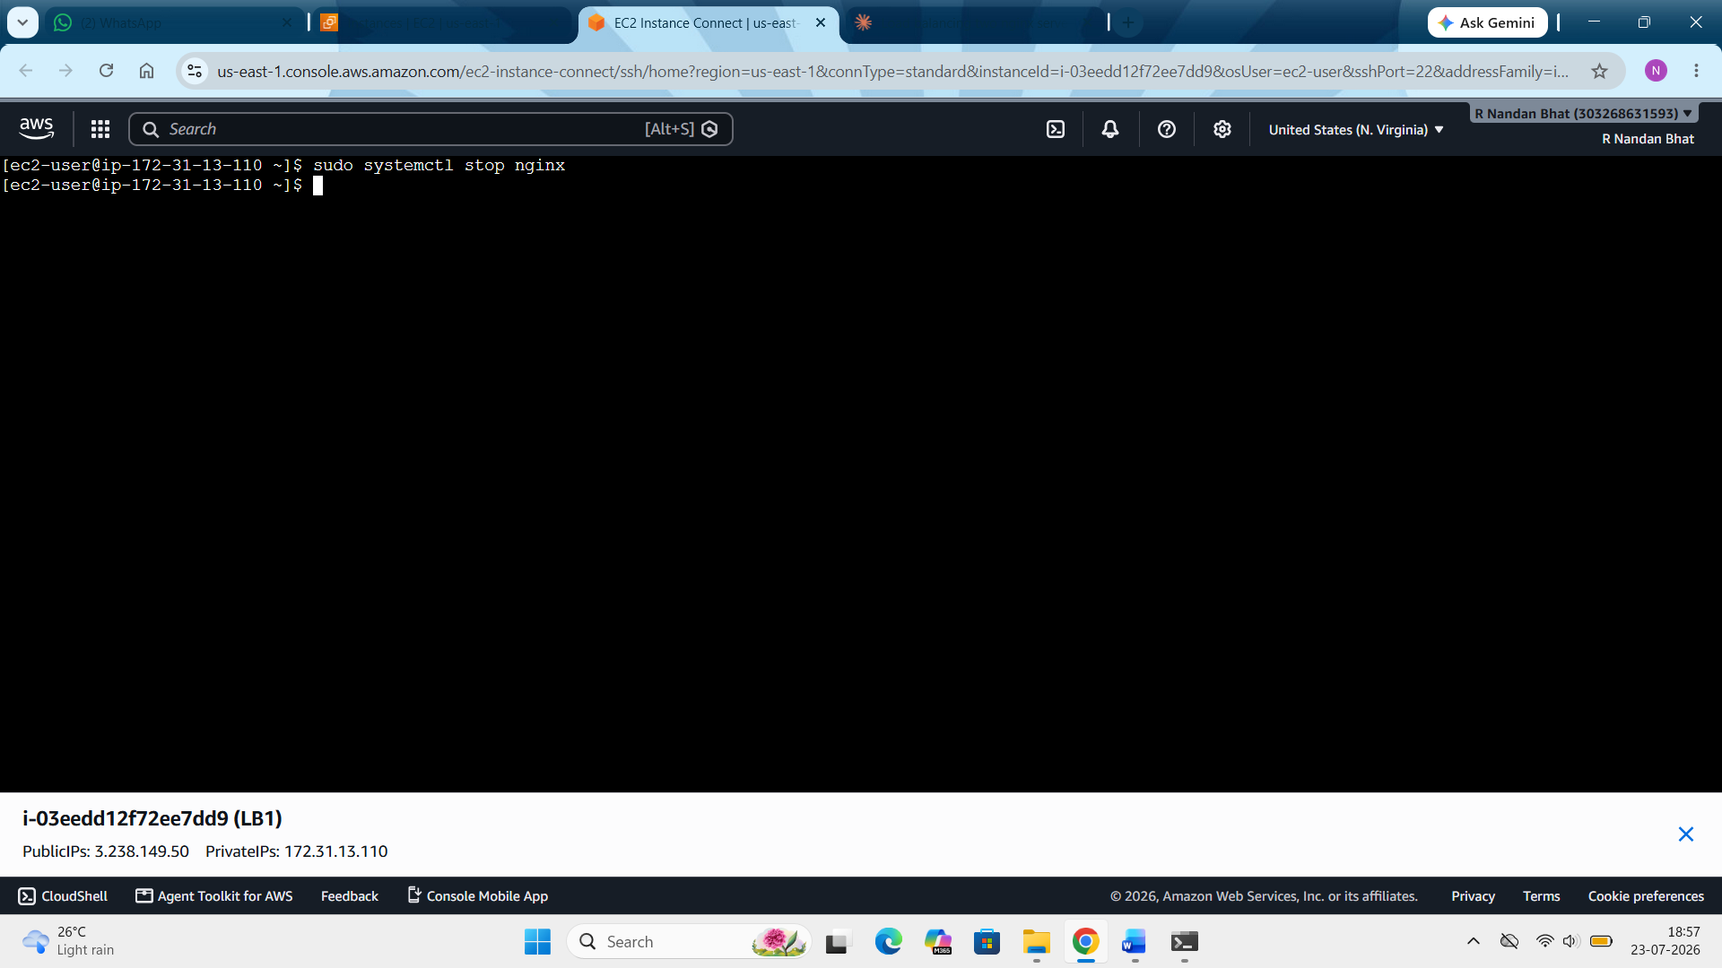
Now go back to powershell and run the curl command again.
i.e. for ($i=1; $i -le 10; $i++) { curl.exe http://web-LB-523235412.us-east-1.elb.amazonaws.com }
Here we will se that only server LB2 responds
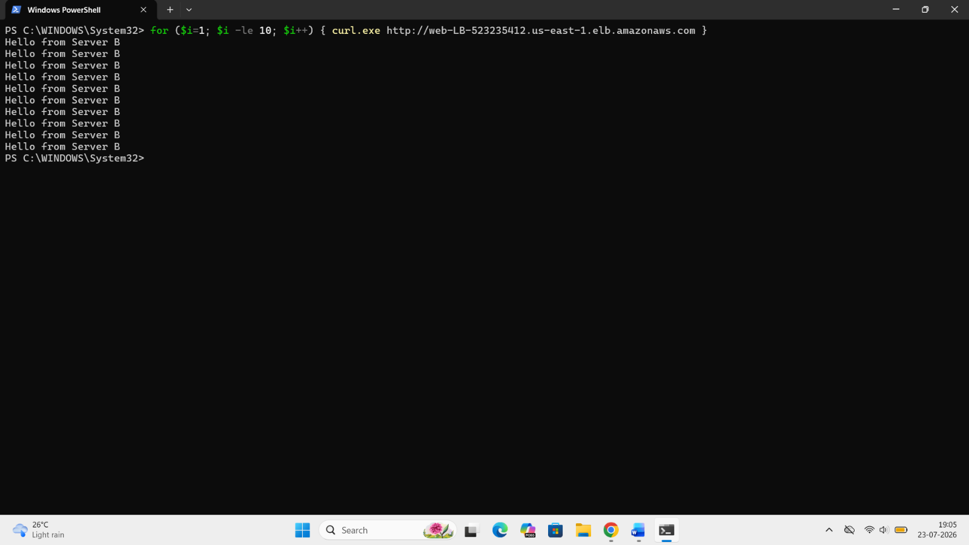

Now again if we go to target group we will see that LB1 will show unhealthy.
EC2 --- load balancing --- target group --- click on created target group.
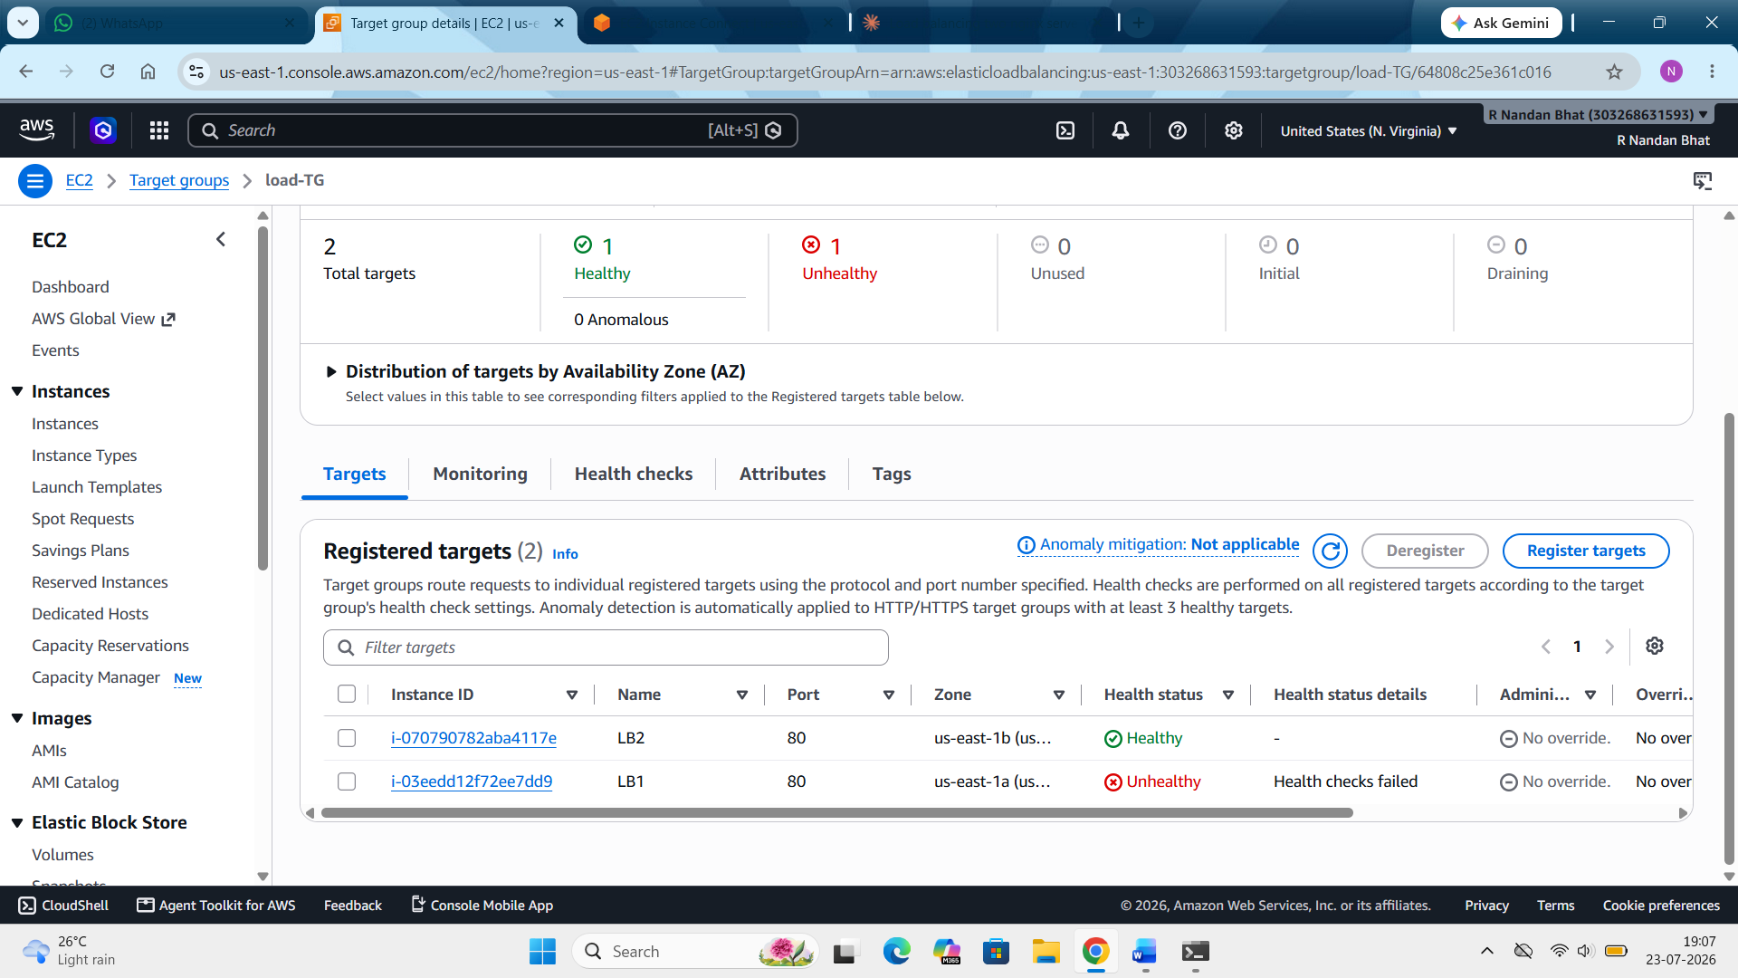
Now restart the nglix in LB1. Now we will again see that the LB1 shows healthy.

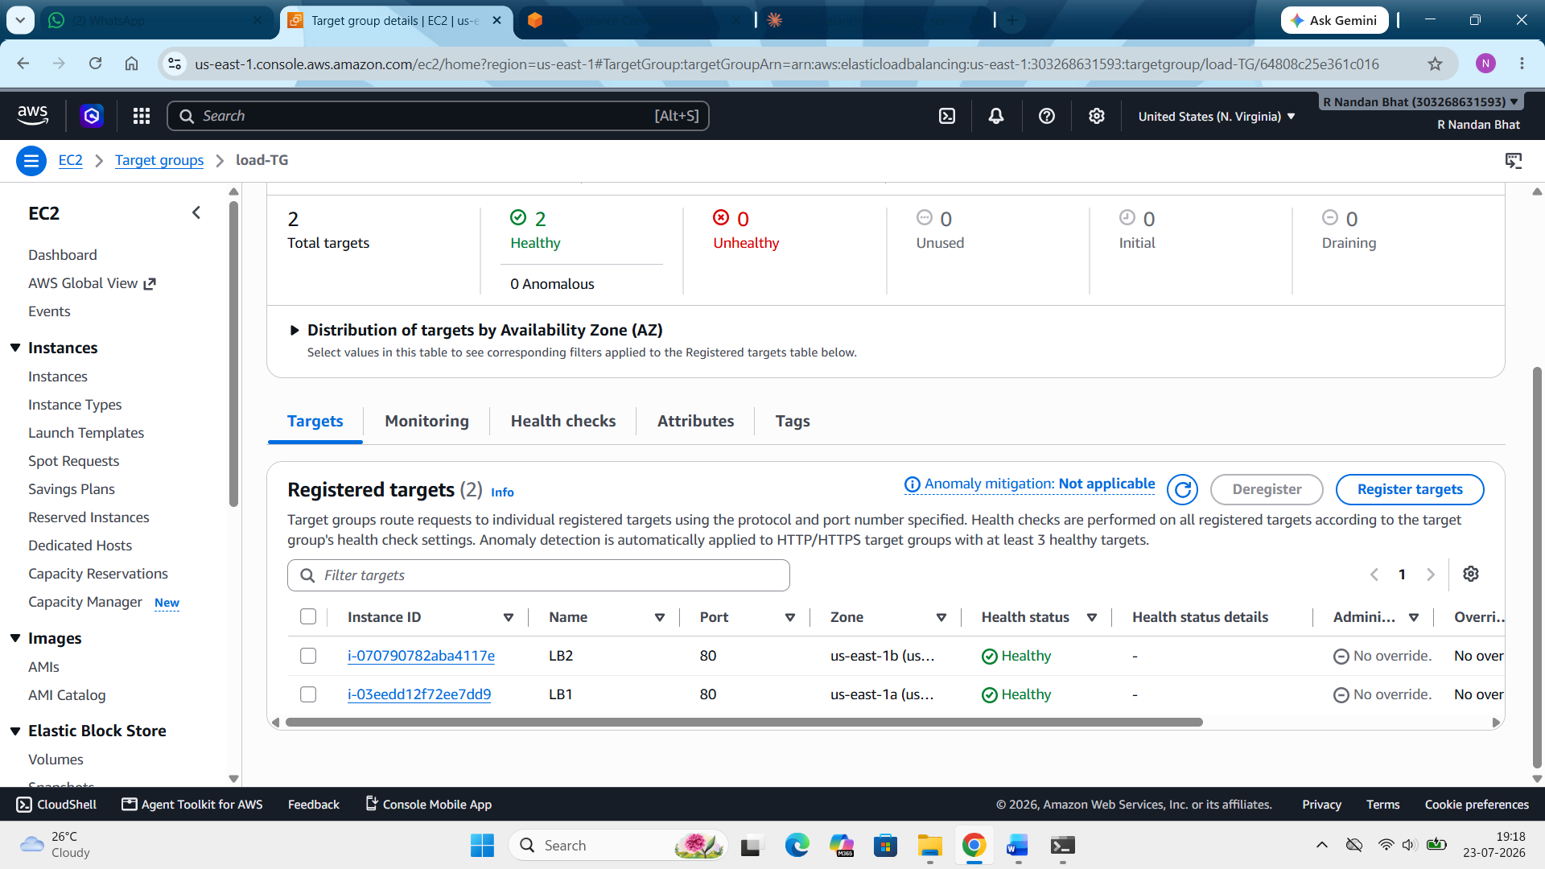

Step 10: Enabling stickiness:
EC2 --- target groups --- select target group (load-TG) --- attributes --- edit --- stickiness --- check turn on stickiness --- type (load balancer generated cookie) --- duration (1 day) --- save changes
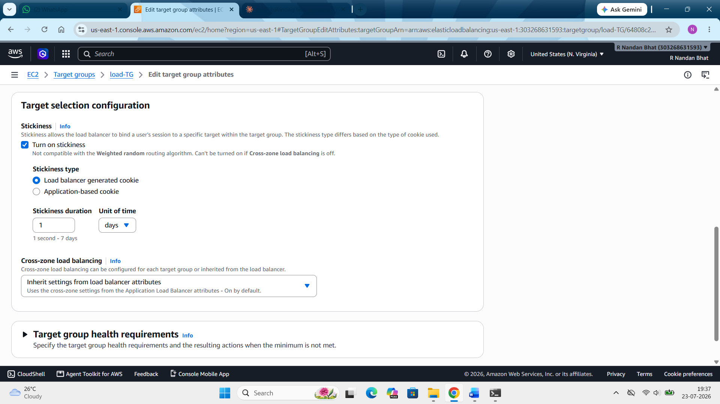

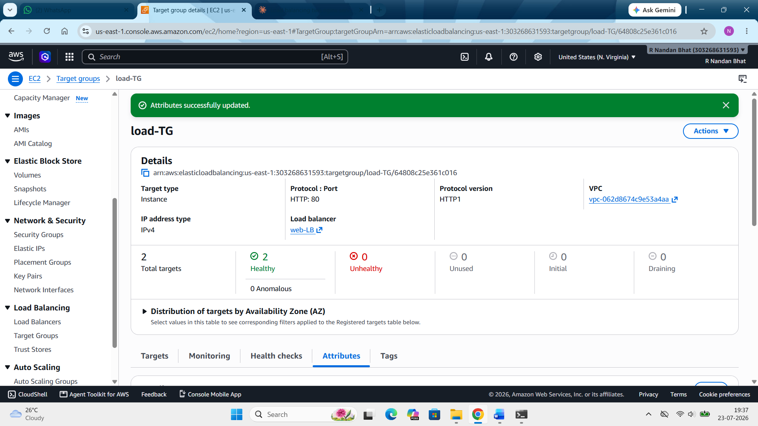

Step 11: Now open powershell and run the command as below
curl.exe -c cookie.txt http://web-LB-523235412.us-east-1.elb.amazonaws.com
This sends one request and saves the ALB's stickiness cookie into a file called cookie.txt in current folder.
for ($i=1; $i -le 10; $i++) { curl.exe -b cookie.txt http://web-LB-523235412.us-east-1.elb.amazonaws.com }
This sends 10 requests, all carrying the same cookie — so the ALB should route all of them to the same server every time, unlike before.
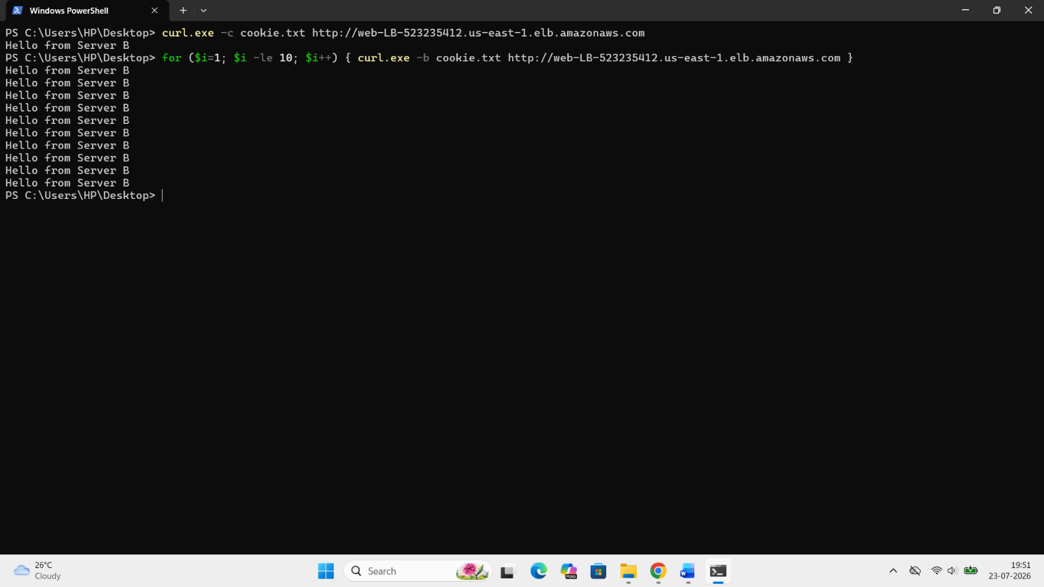
Here we see the same "Hello from Server B" repeated 10 times straight which is different from what we saw earlier where both the servers were doing it alternatively.
Cleanup:
Delete the Load Balancer
Delete the Target Group
Terminate the instances
Delete the security groups

